**STAFFING ANALYTICS**

PROJECT REPORT

**Introduction:**

Our project is based on how a company decides about promotion based on employee’s skills. We have used Machine Learning concepts like Clustering, Decision Tree, K-Nearest Neighbour; to help visualize the conclusion. Each algorithm infers different aspects of the process. We have also attached a portion of an Eligibility test, which shows if an employee is eligible to be promoted based on his skill levels.

We created a webpage and connected it to our Python code using Streamlit . In this webpage, we can choose to view the concepts visually and can also make prediction by attending the eligibility test.

**Technologies used:**

* Clustering
* Decision Tree
* K-Nearest Neighbour
* Graphs and Plots

**Tools used:**

* Jupyter Notebook
* Streamlit

**Installations required:**

* In command prompt (Jupyter Notebook/Visual Studio)
* conda create myenv
* conda activate myenv
* pip install streamlit
* pip install pandas
* pip install seaborn
* pip install matplotlib
* Run the choice.py file by using (streamlit run choice.py) in the command prompt

**Source code:**

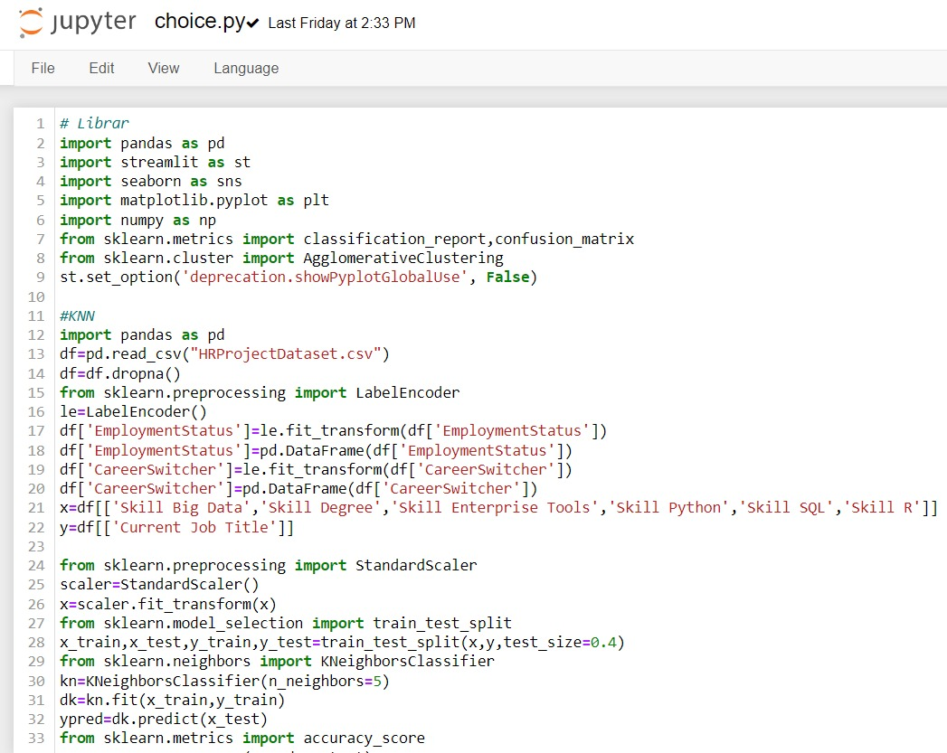

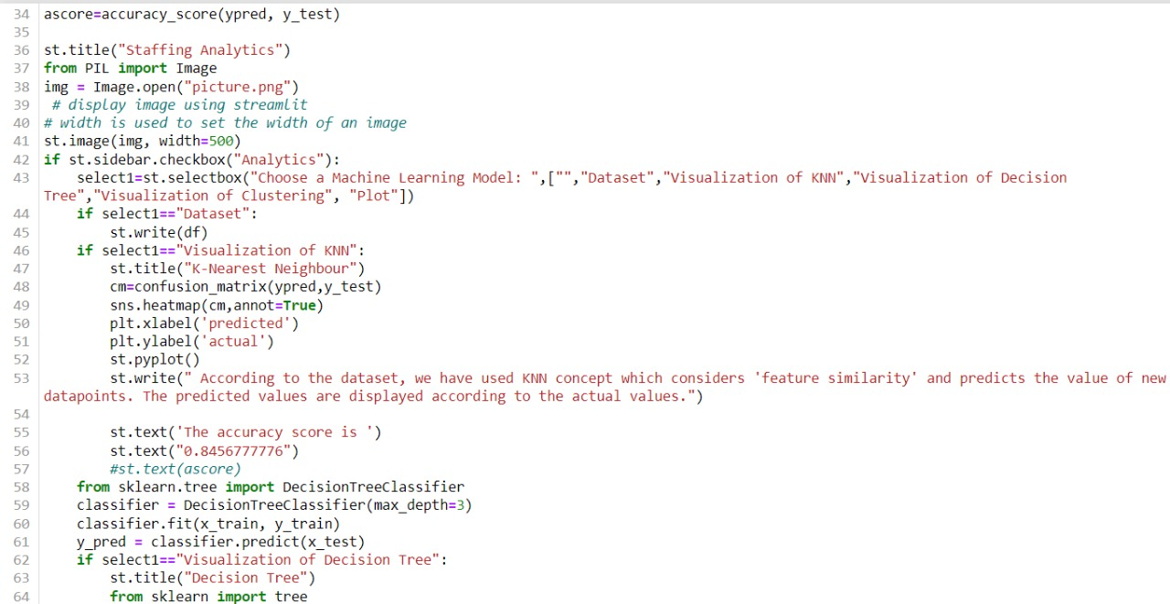

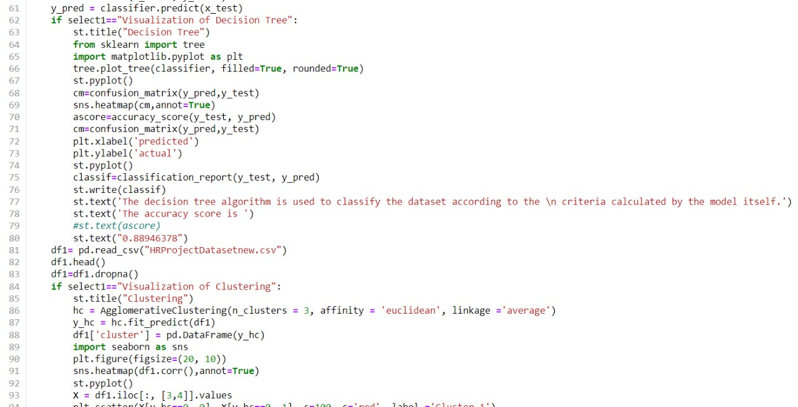

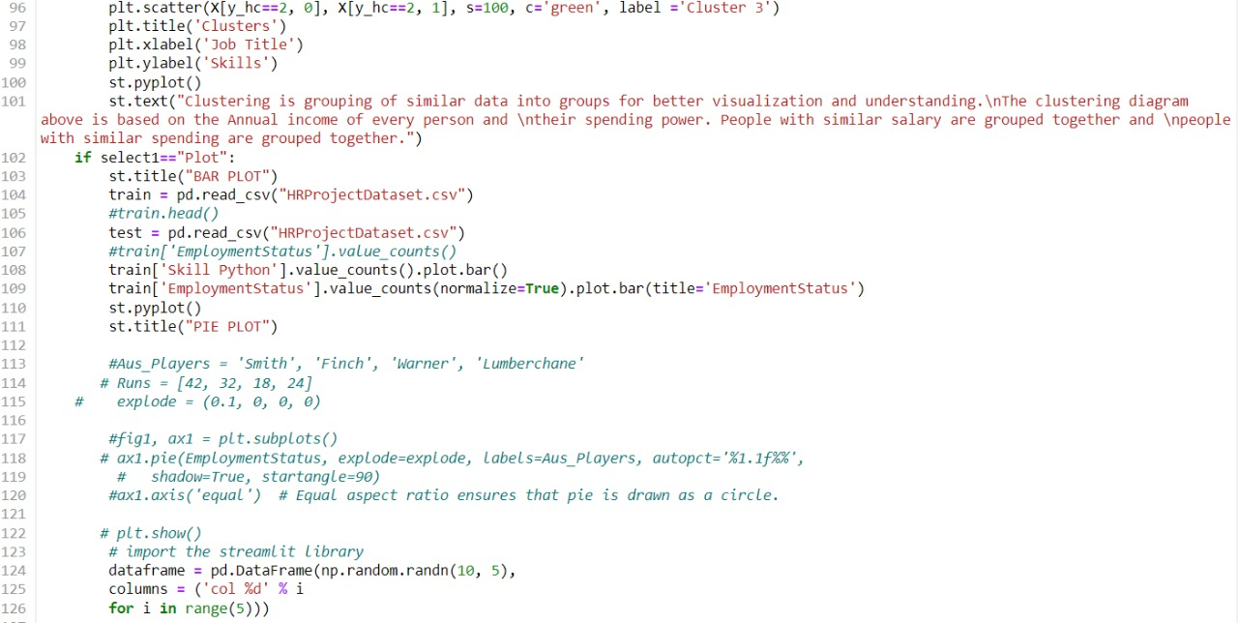

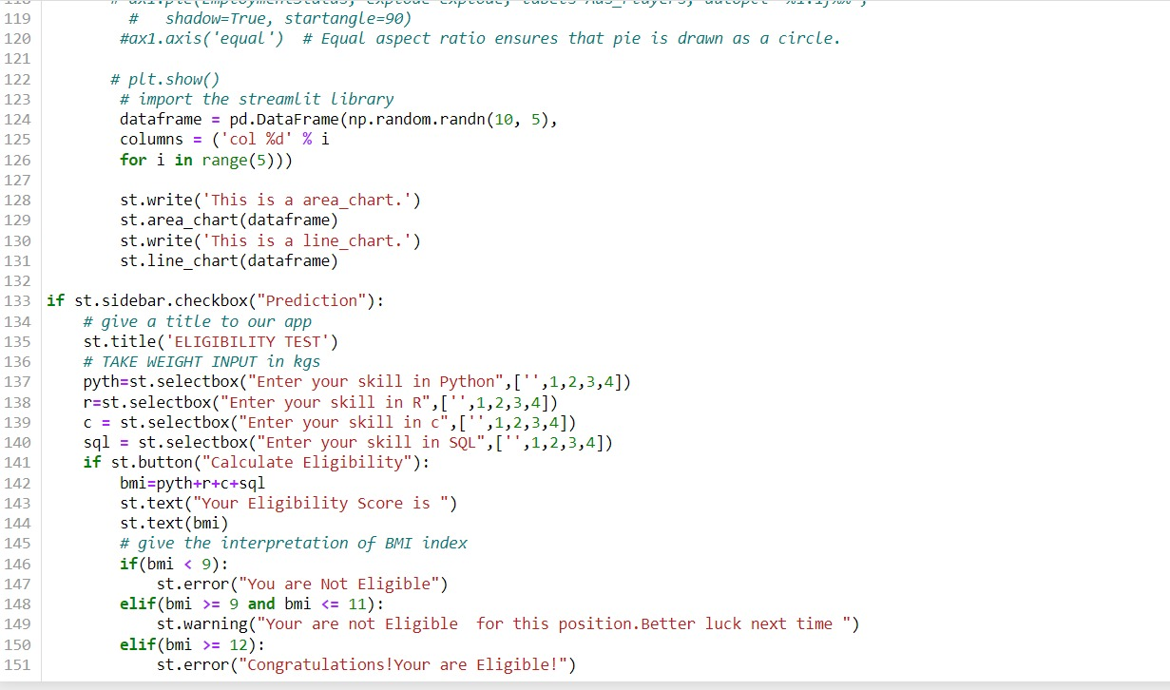

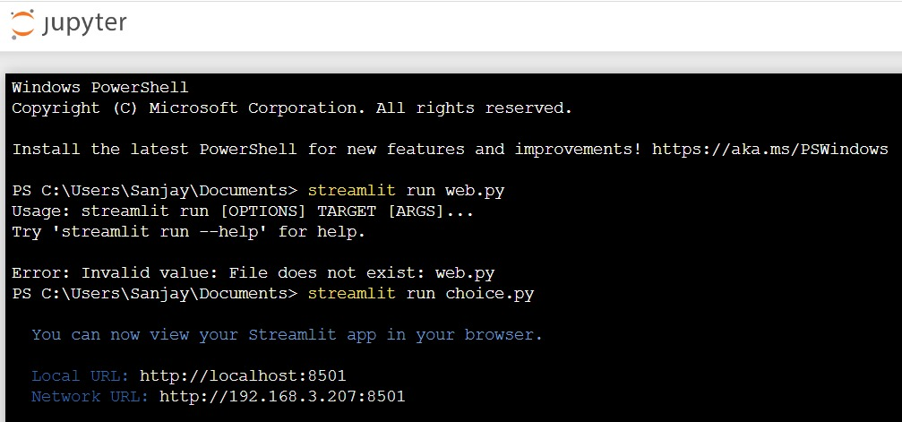

**Output and inference:**

* Dataset

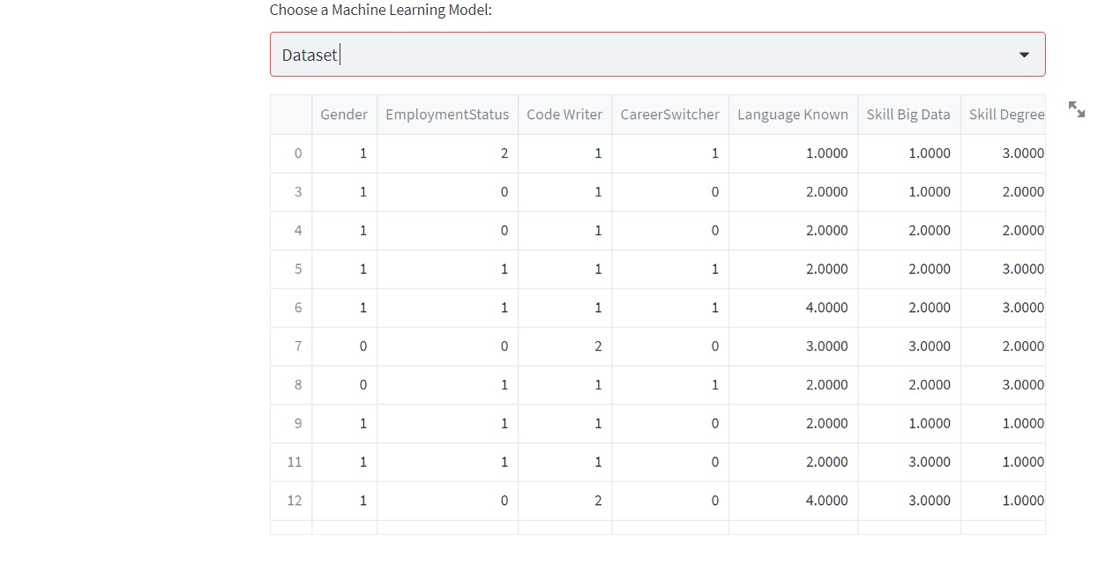

* Home page

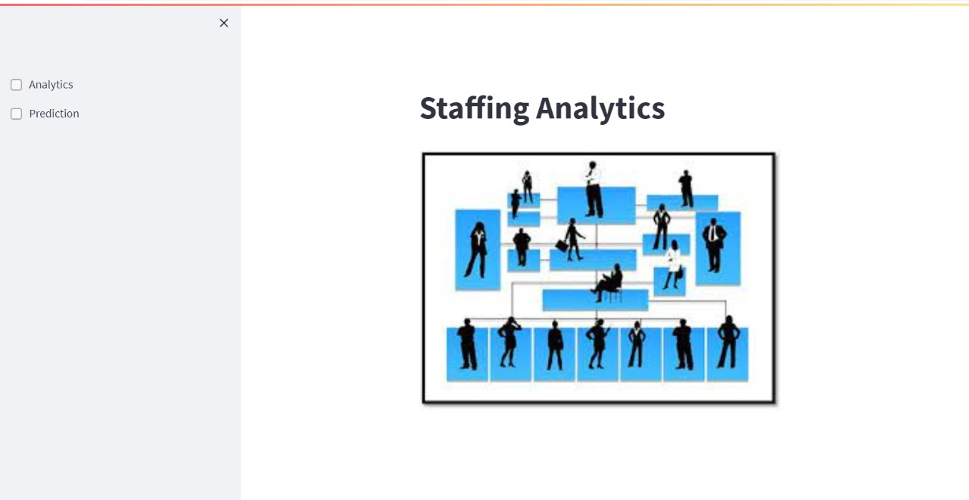

* Models implemented

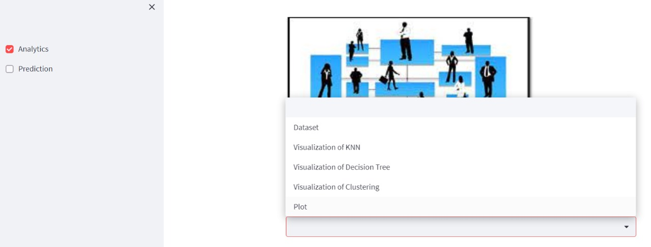

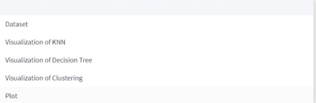

* K-Nearest Neighbour

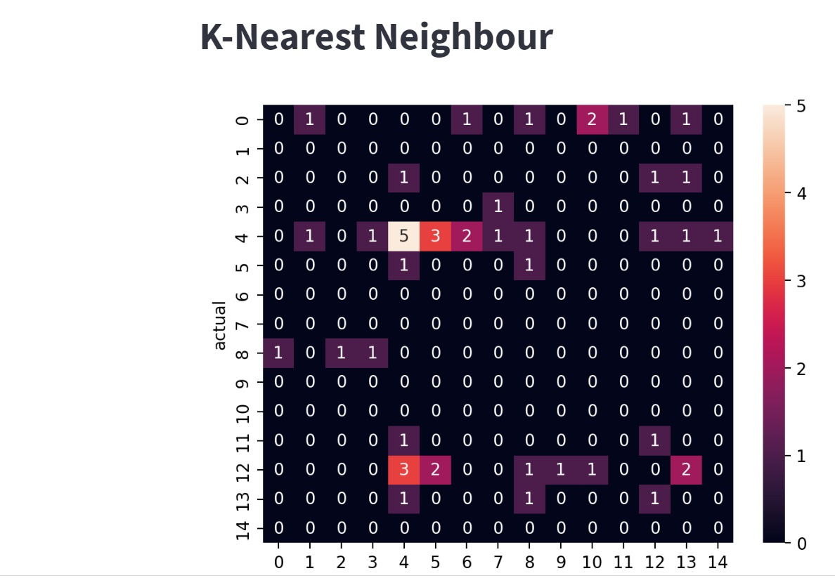

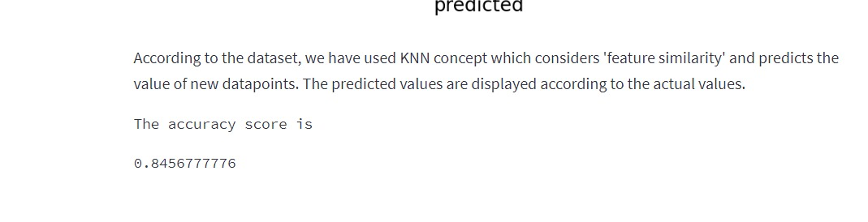

* Decision Tree

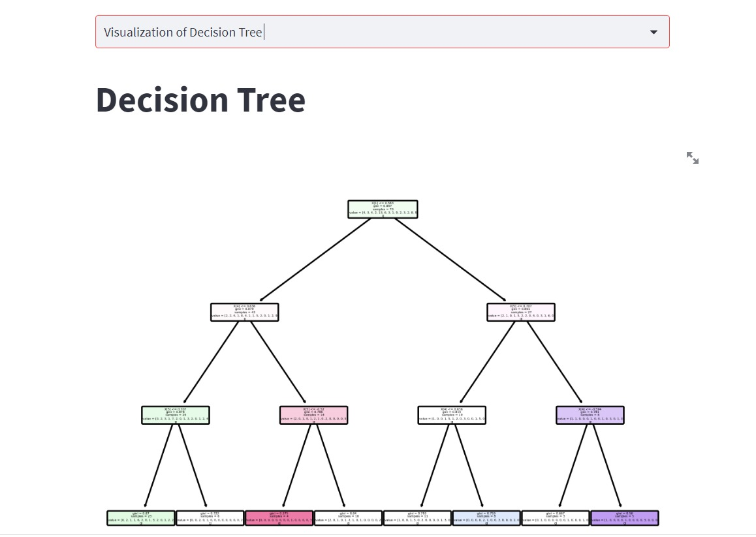

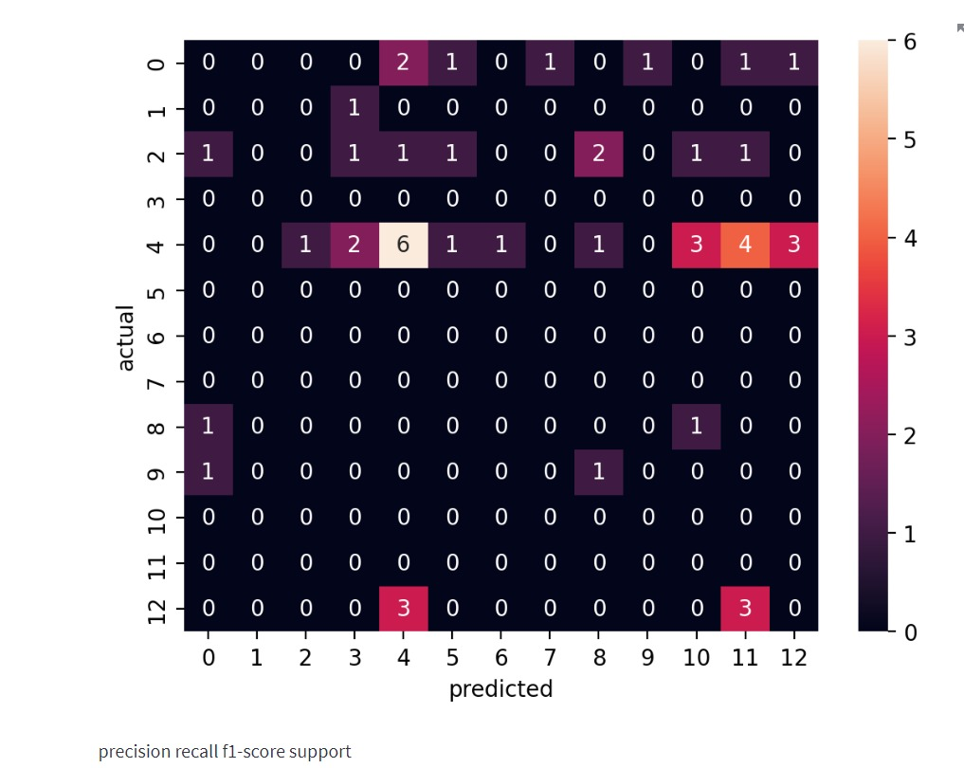

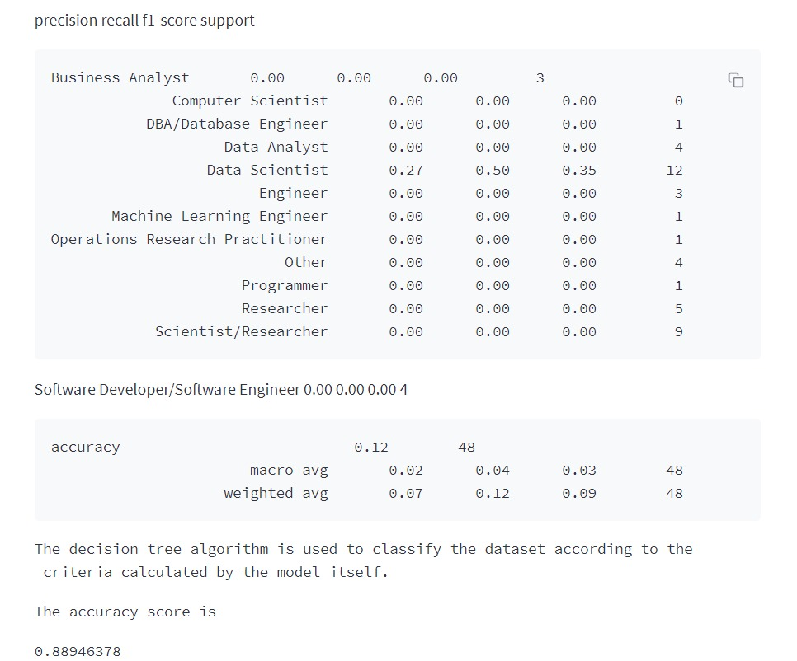

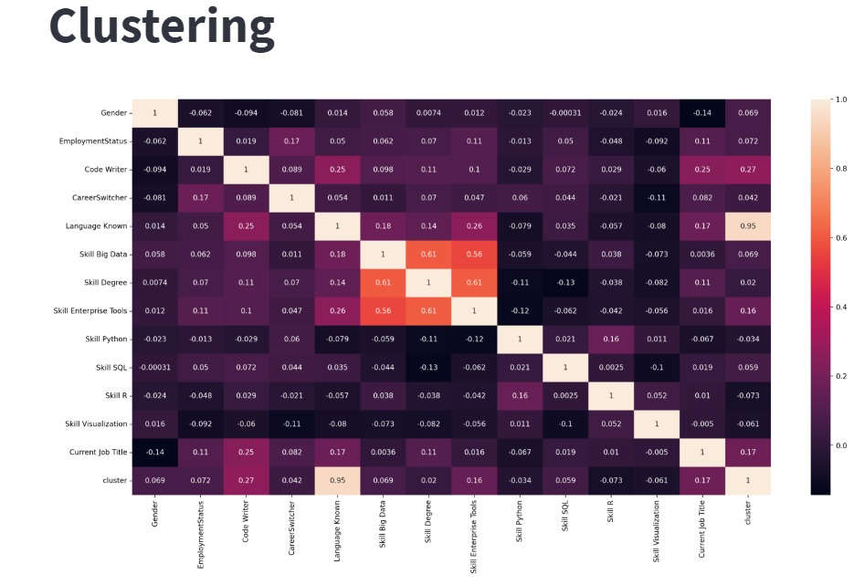

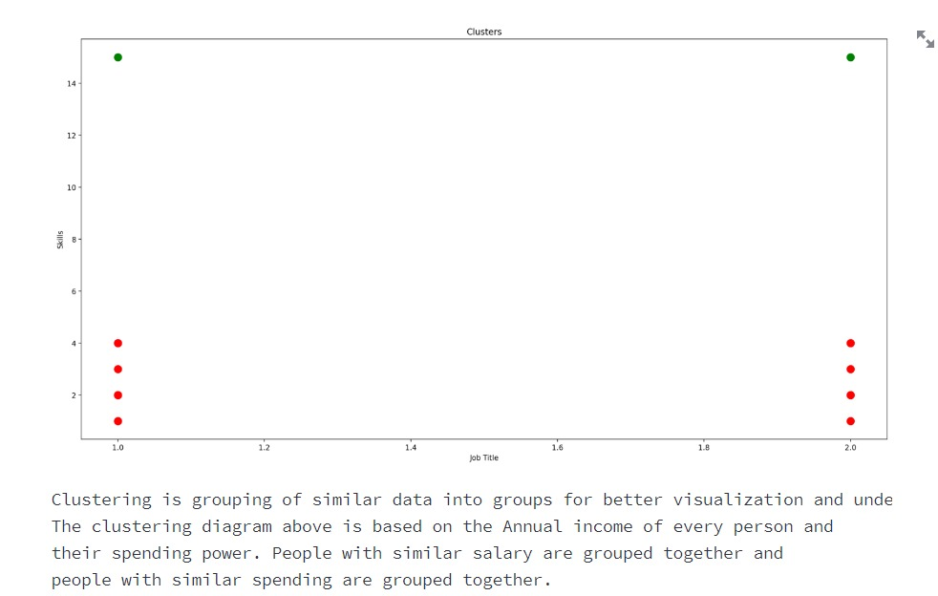

* Graphs

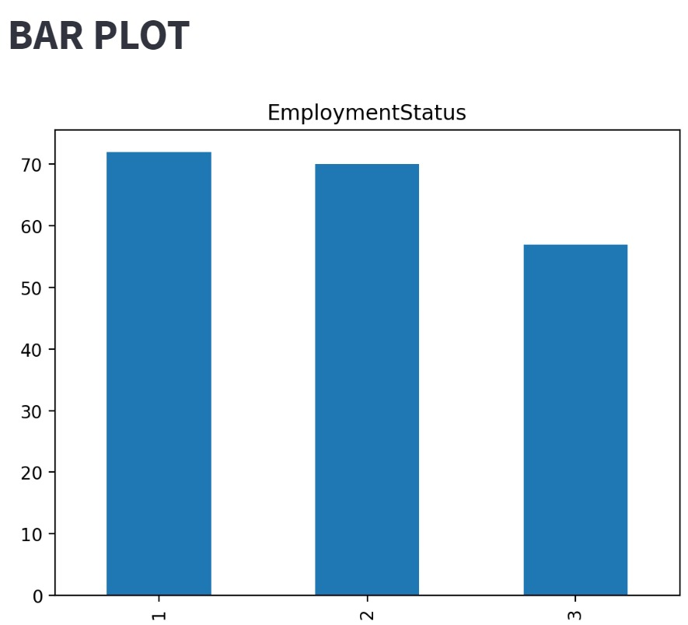

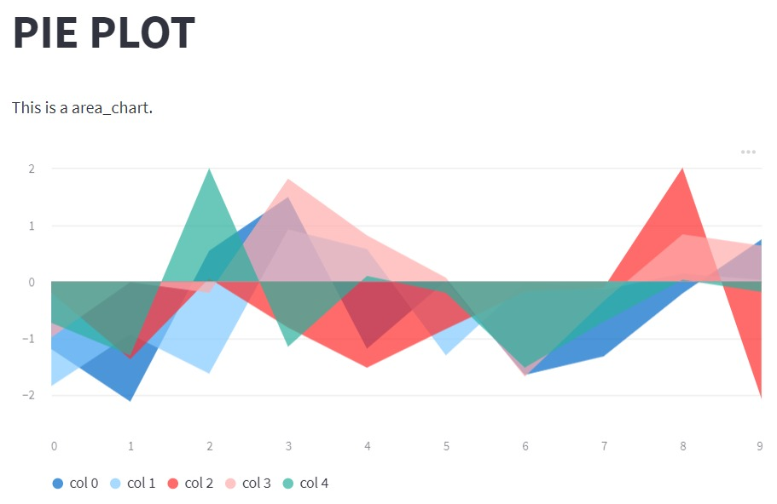

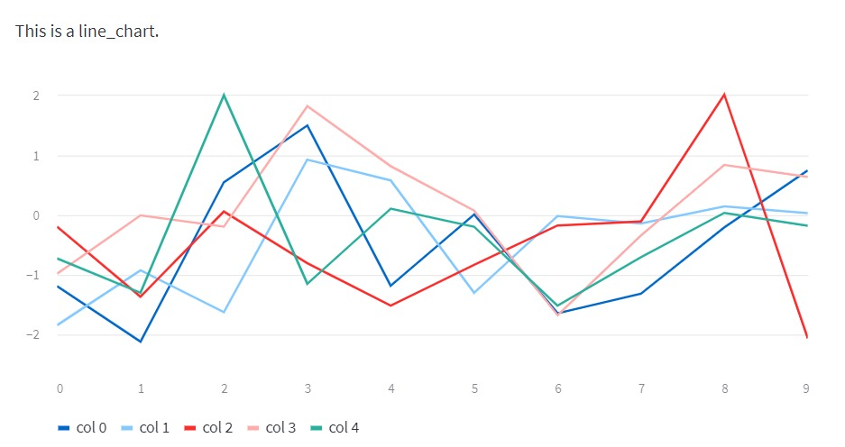

* Predictions

